**Lesson 5 Demo 1**

**Setting Up Jenkins**



Steps to be followed:

1. Download the Java Runtime Environment
2. Download and install the Jenkins app

**Step 1: Downloading the Java Runtime Environment**

* 1. Open the terminal.
  2. Run ***sudo apt-get update*** to update the package lists.
  3. Run ***sudo apt-get install openjdk-8-jdk*** to install the Java Runtime Environment.
  4. Run ***java -version*** to verify the installation. It will print the JDK version as shown below:



**Step 2: Downloading and installing the Jenkins app**

* 1. Open the terminal.
  2. Run ***wget -q -O -*** [***https://jenkins-ci.org/debian/jenkins-ci.org.key***](https://jenkins-ci.org/debian/jenkins-ci.org.key) ***| sudo apt-key add -*** to install Jenkins.



2.3 Run ***sudo sh -c 'echo deb*** [***http://pkg.jenkins-ci.org/debian***](http://pkg.jenkins-ci.org/debian) ***binary/ > /etc/apt/sources.list.d/jenkins.list'*** command.



* 1. Run ***sudo apt-get update***
  2. Run ***sudo apt-get install jenkins*** to install Jenkins.

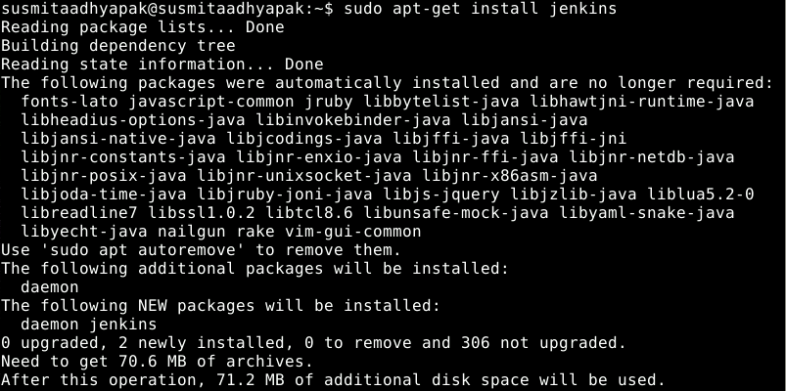

* 1. Run ***sudo service jenkins*** ***status*** to check the status of the installation. Once you verify the status as active, you can press ***Ctrl+z*** to exit from the process.



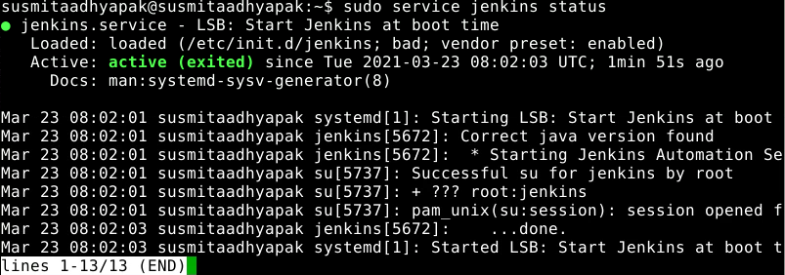

* 1. Run the following commandsto start Jenkins.

***sudo systemctl start jenkins***

***sudo systemctl status jenkins***



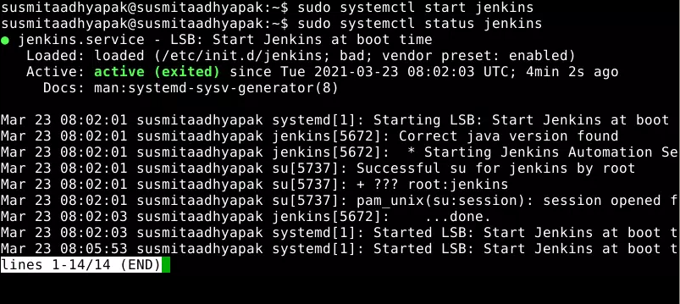

* 1. Open **localhost:8080** in the browser, and you will need to enter the initial password.

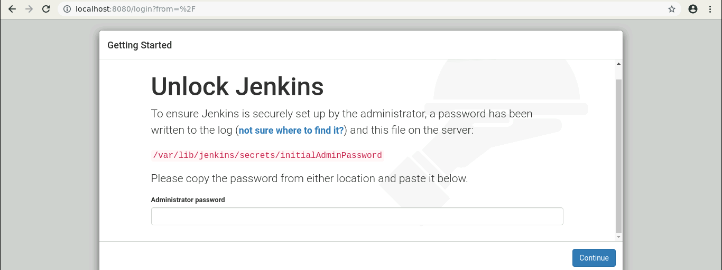

* 1. In your terminal run the following command: ***sudo cat /var/lib/jenkins/secrets/initialAdminPassword***



* 1. Copy this password and paste it on your Jenkins page in the browser.

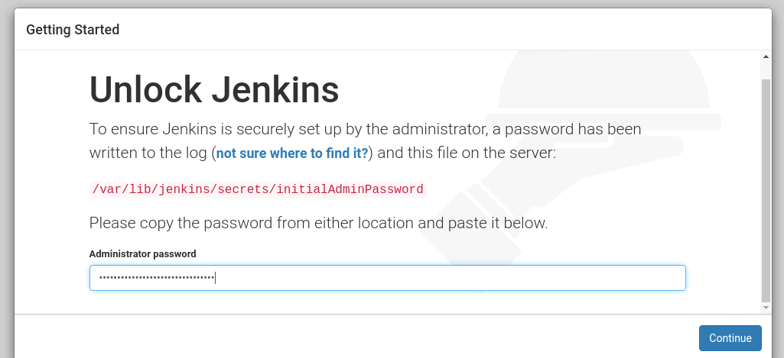

* 1. Now, click on I**nstall the suggested plugins**.

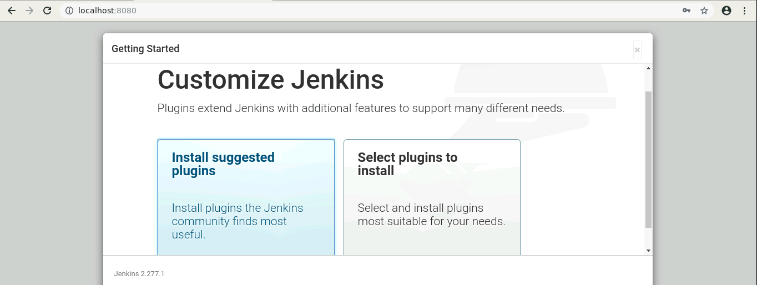

* 1. You can either create an admin user or skip and continue as admin. Select **Skip and continue as admin**.

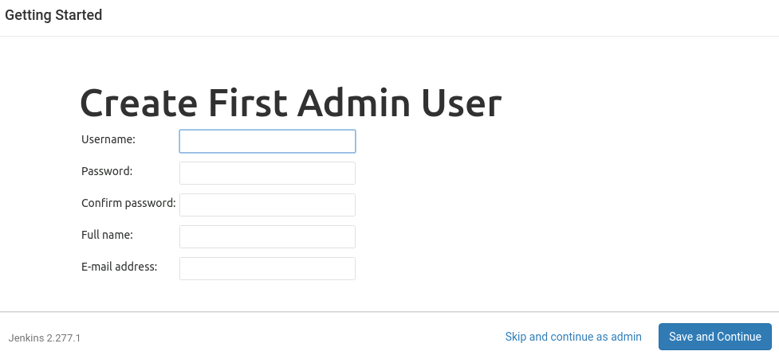

* 1. In the Instance configuration page, click on the **Start using Jenkins** button.

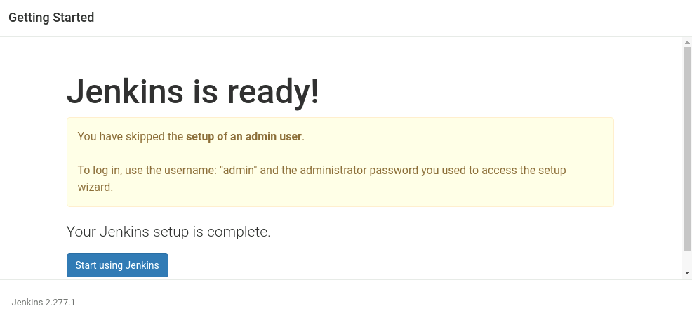

* 1. Now, you can work with Jenkins as shown in the screenshot below.

